# Blaze meter Plugin to Record Script

**🔧 1. Install BlazeMeter Chrome Extension**

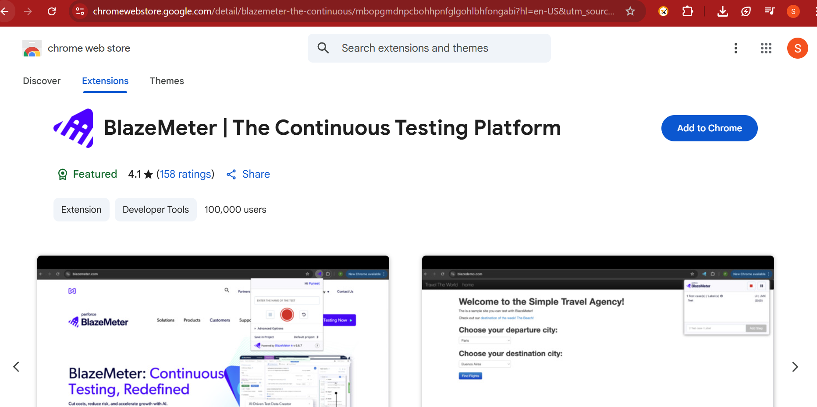

📌 **Steps:**

🔍 Open Chrome Web Store  
🔎 Search: **"BlazeMeter | The Continuous Testing Platform"**  
➡️ Click **"Add to Chrome"** > **"Add extension"**

🖼️ **Icon Appears**:

*(Example icon in browser toolbar)*

**🔐 2. Login / Sign Up for BlazeMeter Account**

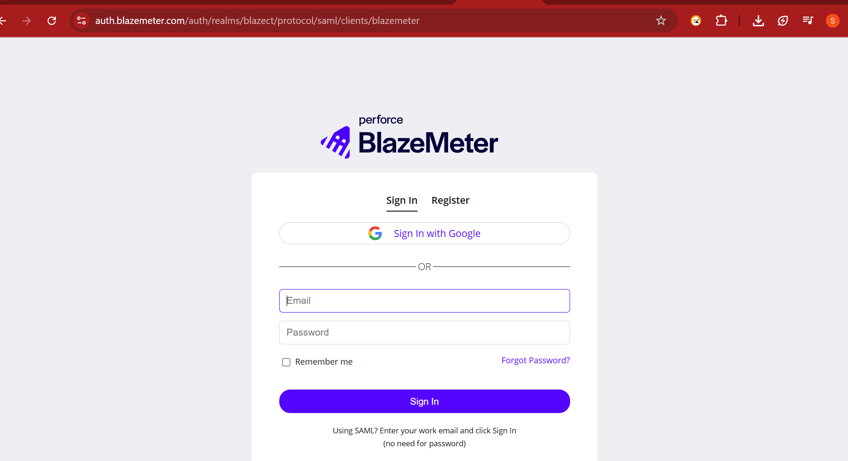

👤 Click the BlazeMeter icon  
🔑 Log in using email credentials, or  
🆕 Sign up if you don’t have an account

📘 **Why?**  
The plugin syncs scripts to your BlazeMeter account to let you:

* Convert recordings to JMeter (.jmx) or Selenium
* Run/load them on BlazeMeter Cloud

**🎥 3. Start Recording a Test Script**

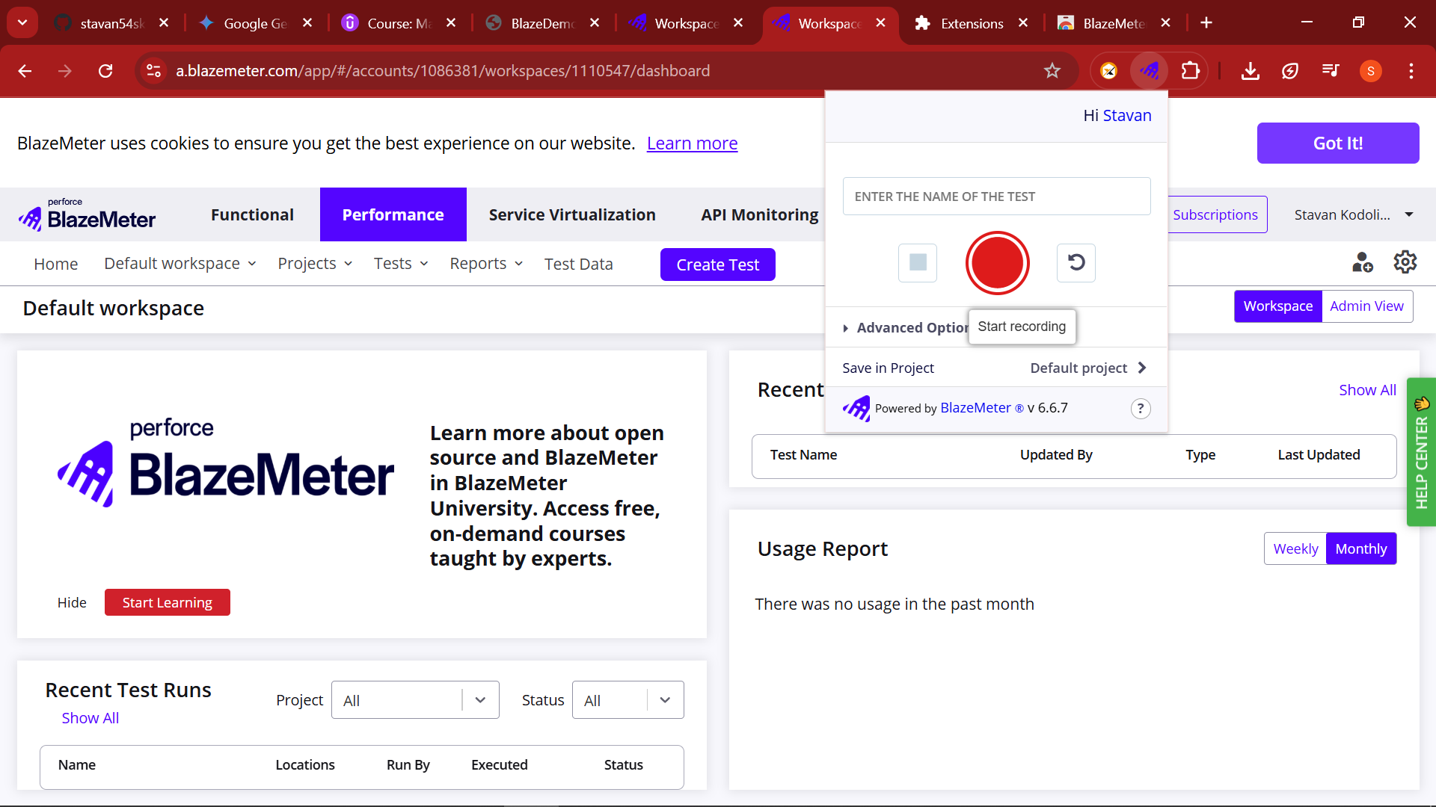

🖊️ Enter test name → e.g., **"LoginFlowTest"**  
⚙️ (Optional) Click Advanced to modify options  
▶️ Click **Start Recording**

🟢 **Extension now records!** It counts:

* 🎯 **UI actions** (Clicks, scrolls)
* 🔗 **JMX items** (HTTP/S requests)

**🖱️ 4. Perform Test Scenario in Web Application**

🌐 Open the web app you want to test  
🎬 Perform actions like:

* 🔗 Navigate to **https://example.com/login**
* 👤 Enter username/password
* ✅ Click login
* 📄 Navigate through the dashboard
* 📤 Submit a form

🛑 **Note**: Every HTTP request and user interaction is captured.

**🧪 Optional: Add Assertions (While Paused)**

⏸️ Pause recording → Right-click on page element  
✅ Choose: “**Add Element Assertion**”  
📝 For example: Assert that “Welcome, Stavan” appears

🔁 Resume recording when done

**✍️ Optional: Rename Steps for Readability**

📝 Click on default step name like:  
"click on div#submit-button" → Rename to → "Login Button Click"

**⏹️ 5. Stop Recording**

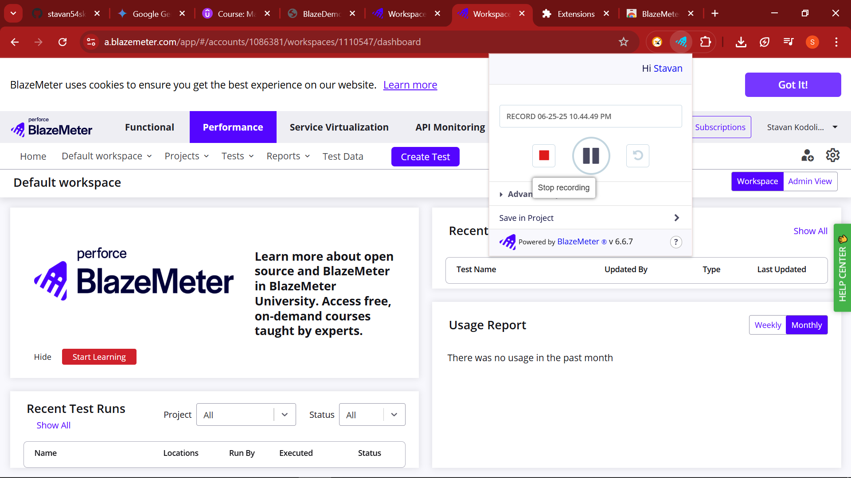

🚨 After finishing, click **“Stop Recording”**

🔄 The extension compiles the test case

**💾 6. Save, Edit or Run the Script**

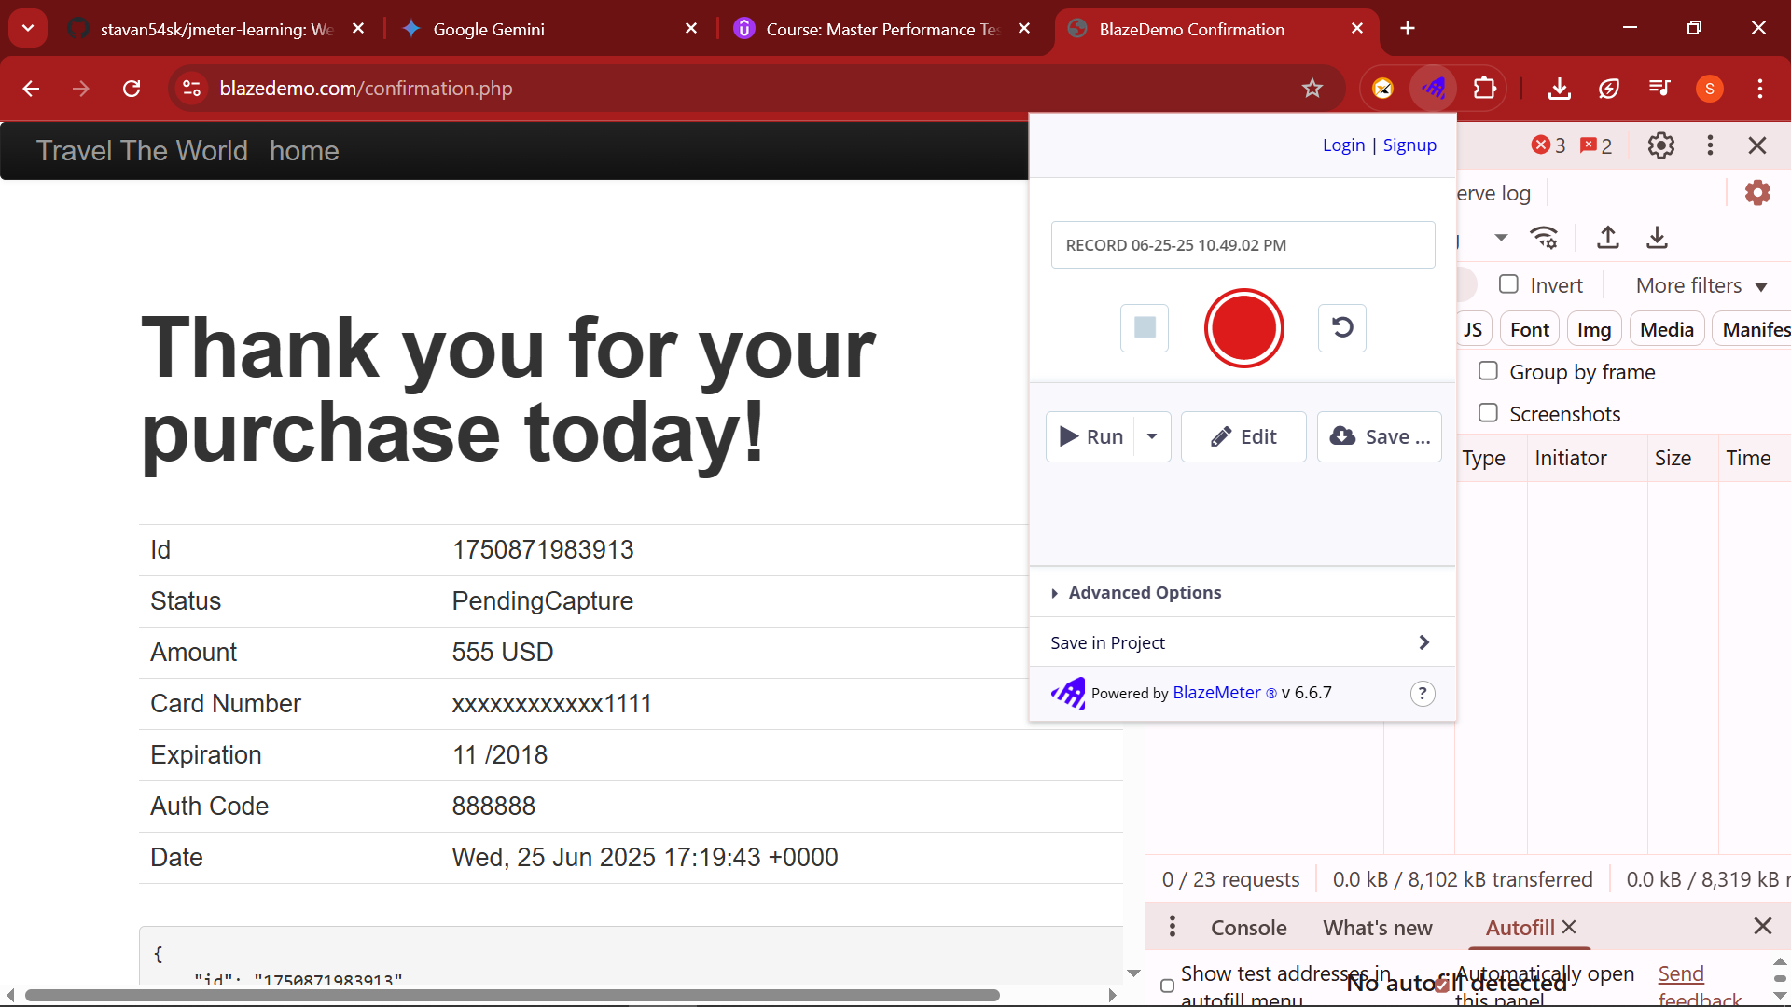

You now get multiple options:

▶️ **Run**:

* Performance Test
* GUI Functional Test
* API Functional Test

✏️ **Edit**:

* Modify in BlazeMeter’s JMeter GUI Editor

💾 **Save As**:

* **.jmx**: JMeter script
* **.yaml**: Taurus YAML
* **Selenium Only**: GUI testing
* **Save in Project**: Directly upload to BlazeMeter platform

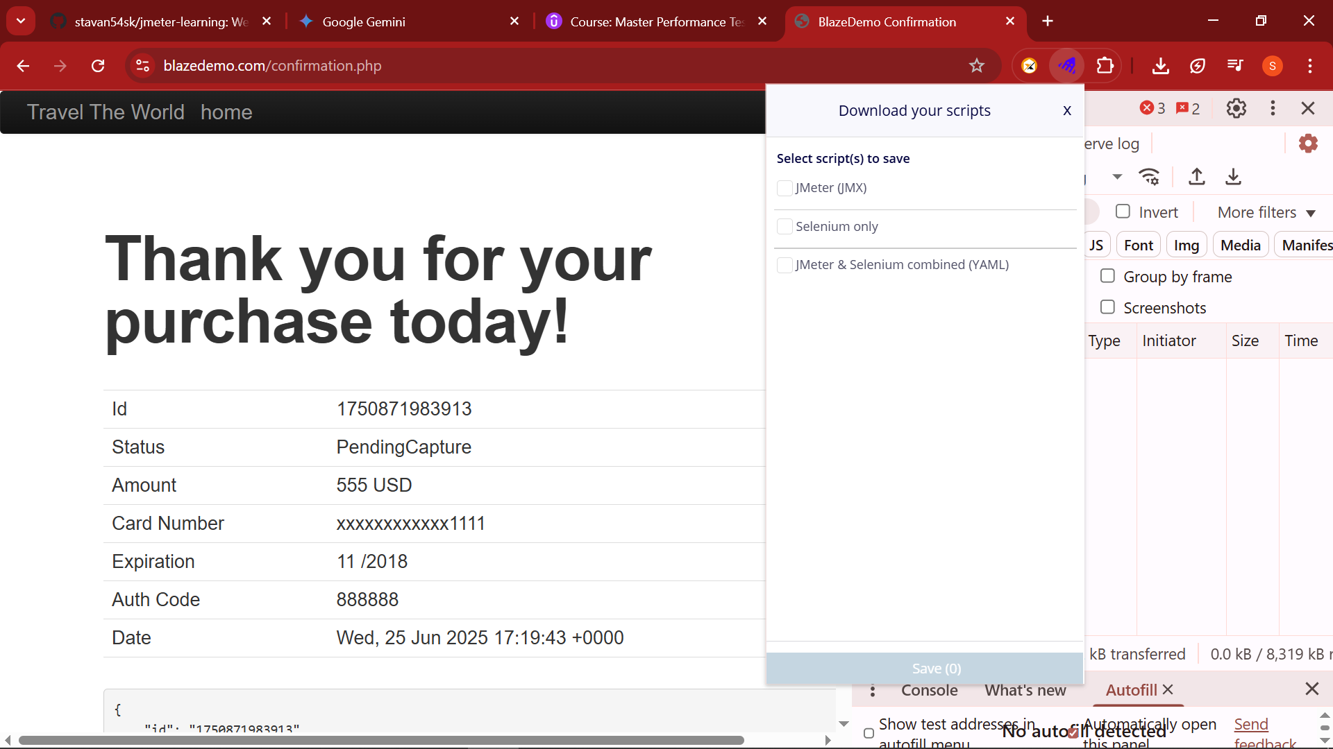

**⭐ Key Benefits with Icons**

| **Feature** | **Description** | **Icon** |
| --- | --- | --- |
| 🔄 Dual Recording | Captures both **HTTP/S + GUI** | 🔗 + 🖱️ |
| 🧠 No Coding Needed | Beginner-friendly recording | 🧒 |
| 🧪 Assertion Support | Add validations visually | ✅ |
| ☁️ Cloud Integration | Direct run on BlazeMeter cloud | 🌩️ |
| 📥 Multi-format Export | Download as .jmx, .yaml, Selenium | 💼 |
| 🎯 Precision | Segment rename for clarity | 🏷️ |

**🧪 Example Test Case**

Let’s say you test a **Login Workflow**:

1. **Navigate to Login Page**
2. **Fill Email/Password**
3. **Click Submit**
4. **Assert “Welcome” message**
5. **Logout**